Global Minimum Variance Portfolio

What Is Global Minimum Variance Portfolio?
A Global Minimum Variance Portfolio (GMVP) refers to an investment portfolio with the least possible spread compared to other potential portfolios of assets with high-risk profiles. Hence, it determines the risk threshold, marking the point where an investor cannot build a more ideal or suitable portfolio below the applicable risk level.
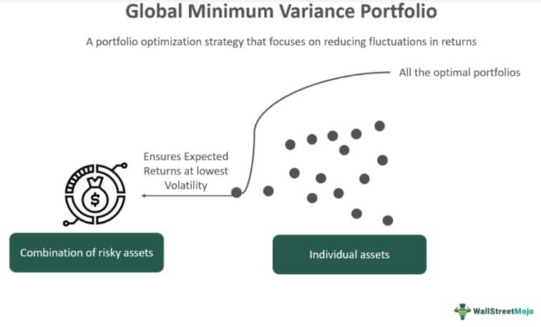Different securities or assets may have distinct or similar risk profiles individually. However, when these investment products are combined in a portfolio, their overall risk can be mitigated by evaluating the mean-variance efficient portfolios lying on the efficient frontier. The global minimum variance portfolio is the point on the left of the boundary of this efficient frontier.
- A Global Minimum Variance Portfolio or GMV portfolio is a portfolio of assets with a high-risk profile that has minimal volatility or variance than all other optimal portfolios.
- Such portfolios are built to achieve the minimum possible portfolio variance for a given set of risky assets by selecting asset weights that minimize the variance.
- Harry Markowitz proposed the concept of portfolio selection in 1952.
- The GMV portfolio is represented as the left-most point on an efficient frontier consisting of the minimum variance portfolios presenting all the feasible investment opportunities.

Global Minimum Variance Portfolio Explained
The Global Minimum Variance Portfolio (GMVP) is a version of the mean-variance portfolio theory proposed for portfolio selection by economist Harry Markowitz in 1952. Since then, the field of finance has witnessed rapid expansion.
Markowitz's novel concept of minimizing portfolio variance while adhering to budget constraints has given rise to the widely acknowledged and commonly employed GMV portfolio for determining risk-adjusted returns. Budget constraints comprise factors like capital available for investment, transaction costs, liquidity expectations, etc.
It is a popular portfolio optimization strategy among risk-averse investors. It outlines the lowest achievable portfolio variance or risk given the assets chosen by an investor. Since the focus is on minimizing the risk, investors may, at times, accept lower returns on their portfolio than the returns achievable through other points or portfolio choices.
To understand the GMV portfolio, one must first understand the efficient frontier. It is the curve that is formed of all the optimal or efficient portfolios that represent various return possibilities based on investors' risk-taking capacity.
Out of all these potential investment opportunities, the most efficient portfolio is the global minimum variance portfolio that has the lowest return volatility, i.e., minimal risk and fair return potential. Before making a decision, an investor must check their risk tolerance level and study various points (portfolio choices) on the efficient frontier. Let us go through the following graph for a clearer picture.
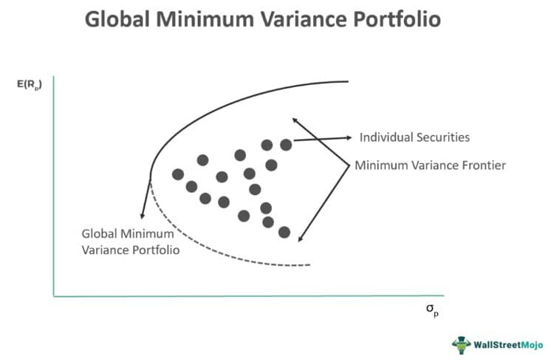While the GMV portfolio looks promising on theoretical grounds, its practical use or implementation poses various complications. The foremost concern is ascertaining the asset return distribution criteria.
Moreover, it is challenging to determine the correlation coefficient, as analysts cannot determine the population covariance matrix of the asset returns with any level of accuracy or reliability. Taking only historical information into account may lead to the wrong conclusions. It must be noted that despite these hurdles, risk-averse investors prefer applying the GMVP strategy.

Formula
In this section, let us study this modern portfolio theory concept in detail. The GMV portfolio can be derived using a global minimum variance portfolio Excel template.
Consider that a portfolio has only two assets; the formula for determining the global minimum variance portfolio is as follows:
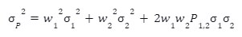Here,
- σP2 is the global minimum variance portfolio;
- w1 is the weight of Asset 1;
- w2 is the weight of Asset 2;
- σ12 is the variance of returns of Asset 1;
- σ22 is the variance of returns of Asset 2;
- P1,2σ1σ2 is the covariance of returns of Assets 1 and 2, where the coefficient correlation of the assets is the standard deviation of the returns of Assets 1 and 2, respectively.

